Influence of coarse additions on the plasticity and toughness of soil mixtures, Part II: Effect of sand angularity and sand size uniformity.

last compiled Wed. 2022-06-01, 9:14 AM

# Abstract

The Atterberg limits may offer a useful means to evaluate baseball infield soils because they quantitatively relate soil behavior to water content. Prior research has demonstrated that liquid and plastic limits (LL and PL) of sand-clay mixtures are affected by the quantity and type of admixed sand, but these studies have used sand exclusively <425 μm and little attention has been devoted to sand angularity and sand-size uniformity.

This research was conducted to clarify the effect of sand angularity and sand-size uniformity on the Atterberg limits of soil mixtures containing a range of sand contents and a significant mass percentage >425 μm.

Experiment 1 compared the effect of mixing either an angular or a round sand (both 0.5-1 mm) with a kaolinitic clay at sand content 0-80%. Little difference was observed in LL and PL, suggesting angularity plays a minimal role on mix performance.

Experiment 2 compared the effect of mixing one of two sands having similar D50 (0.42 and 0.49 mm) but varying uniformity (uniformity coefficients of 1.9 vs. 3.9) with an illitic clay at sand contents between 0-80%. The high-Cu sand had slightly higher LL and PL at equivalent sand content. Mixtures including the high-Cu sand maintained their plasticity to higher sand content (~72.5%) than those produced with the low-Cu sand (~67.5%).

Calculations for the threshold fines content (TFC) and intergranular porosity agreed closely with the experiments, indicating a potential to estimate TFC from sand porosity alone.

# Introduction

The Atterberg limits are used by geotechnical engineers to classify fine-grained soils (ASTM International, 2017). These tests include the liquid limit (LL) and plastic limit (PL). The tests were developed for fine-grained soils, but research has shown the amount and properties of admixed sand also affects the test results (Atterberg, 1911; Dumbleton and West, 1966; Sivapullaiah and Sridharan, 1985; Barnes, 2013). Particle angularity and particle-size uniformity are known to affect the behavior of granular materials, but their effects are less clear for soils which contain significant amounts of fines (Mitchell and Soga, 1993; Hojae and McNitt, 2001; Holtz et al., 2010; Miller and Henderson, 2011; Zuo and Baudet, 2015).

## Atterberg limits of soils having varied sand angularity

Particle angularity is defined as the roughness of a particle surface (Brady and Weil, 2007). Mathematical definitions have been used to quantify angularity, although it is often estimated using representative charts developed from the metrics (Wadell, 1932; Krumbein, 1941; Suhr et al., 2020).

Research on the importance of sand angularity in soil mixtures has produced mixed results. Dumbleton and West (1966) tested mixtures of various types of coarse particles with either kaolinite or montmorillonite. Dumbleton and West (1966) demonstrated that mixtures including angular sand had higher LL and PL relative to mixtures produced with equivalent amounts of glass spheres. The authors maybe researcher? To distinquish Dumbleton from us? postulated that angular particles had more surface area compared to the spheres, requiring additional water to coat their surfaces before they could slide or flow past one another.

Findings by Sivapullaiah and Sridharan (1985) differ from those of Dumbleton and West (1966). Sivapullaiah and Sridharan (1985) mixed either angular or round particles of the same size fraction (150 μm – 75 μm) with bentonite clay at sand contents ranging from 20-95 %. Sivapullaiah and Sridharan (1985) reported no difference in the liquid or plastic limits due to angularity.

## Atterberg limits of soils having varied sand uniformity

Particle-size uniformity, or more simply “uniformity,” is defined as the similarity of diameters across particles within a soil. The coefficient of uniformity (Cu) is a commonly used mathematical definition (Adams and Gibbs, 1994; Holtz et al., 2010). Cu is the ratio between the particle diameters at which 60% and 10% of the sample is finer.

Little research is available on the effect of sand uniformity on the Atterberg limits of soil mixtures. This is probably because the upper boundary of allowed particle sizes in ASTM D4318 (425 μm) limits the total range of sand particle diameters. Dumbleton and West (1966) reported that mixes produced using non-uniform sand had similar Atterberg limits to mixes containing sand from a single mesh size. However, all of the sand in their experiment was between 425 and 53 μm, limiting the potential variability in uniformity. Efficient particle packing - defined as the ability of smaller particles to fit comfortably in the voids between larger particles - is limited when the majority of particle diameters fall within a factor of 10 (Lade et al., 1998a). It is possible that a larger uniformity effect on LL and PL would be observed if coarser sand were included in the mixture to create a higher Cu.

At very low sand contents, angularity and uniformity are probably unimportant because the sand grains are suspended in a clay-water matrix and do not play a significant? Or measurable? role in transmitting loads through the soil skeleton. At higher sand contents, the coarse grains begin to contact one another and the nature of these contacts will affect the behavior of the bulk soil (Mitchell and Soga, 1993; Zuo and Baudet, 2015). As sand content continues to increase, the soil becomes nonplastic because plasticity is not observed in soils dominated by granular particles (Mitchell and Soga, 1993; Holtz et al., 2010). The behavior transition between sand-like and fines-like behavior occurs at a fines content termed the threshold fines content (TFC) (Zuo and Baudet, 2015; Sibley and Polito, 2020).

Because less-uniform sands have less total void space, one could expect these sands to require a lesser proportion of fines to fill their interstices, compared with a more uniform sand. Therefore, sand uniformity could alter the upper limit of sand content at which the soil will exhibit plasticity.

# Objectives

Recent research has demonstrated that the LL and PL tests can be performed on soils containing a significant amount of particles 2000-425 μm (Mascitti and McNitt, this issue). It is unclear what effect sand shape and uniformity play on the Atterberg limits of soil mixtures containing these coarser sands.

The present research was conducted to answer two questions:

1. How does sand particle angularity affect LL and PL of sand-clay mixtures when total sand content and sand particle size are held constant?
2. How does sand-size uniformity affect LL and PL of sand-clay mixtures when total sand content and *average* sand particle size (D50) are held constant?

# Materials and methods

Two experiments were conducted to evaluate the effects of sand angularity and uniformity on the Atterberg limits of soil mixtures containing a range of sand contents.

The minimum and maximum void ratios of the sand components used in each experiment were characterized using modified versions of ASTM (2011, 2016). In the minimum void ratio test , a single lift of sand was dynamically compacted using a specified drop weight. In the maximum void ratio test, the sand was carefully loosely? poured into a container of known volume and leveled with a straight edge.

After mixing the sand with the relevant clay component, LL and PL tests were performed on a series of mixtures to evaluate the effect of sand angularity or uniformity.

The liquid and plastic limit tests were performed according to a modified version of ASTM D4318 (ASTM International, 2018). The modification eliminated the wet-sieving procedure so particles between 2000 and 425 μm remained in the sample (Mascitti and McNitt, this issue). At least four data points were collected during the LL test in order to plot the flow curve. In the PL test, 3 threads were rolled to the crumbling condition before being weighed to ± 0.001 g and oven-dried. In both experiments the average of the 3 results was used to represent the PL of each sample.

## Mixing procedure

All mixture components were air-dried and their water contents were determined gravimetrically. The clay components were pulverized and passed though 0.25 mm screen. Sands were mixed by hand with the relevant clay component until visually homogeneous. The mixture component percentages were adjusted for the trace amounts of particles 2000-53 μm in the clay components. Final mixture percentages are expressed as oven-dry mass.

## Treatment descriptions

Experiment 1 evaluated mixtures containing equivalent amounts of one of two sands having varying angularity. Two sands were selected based on their classification as angular and well-rounded. The sands were visually classified using a microscope and the chart from Baker (2006) (Figure **1**). Each sand was then repeatedly sieved to remove particles <0.5 mm and >1 mm. The single-mesh sands were mixed with a kaolinitic clay to yield mixtures having 0, 20, 40, 60, 70, 75, and 80 % sand. The LL of the kaolinitic clay was 43 and its PL was 17, yielding a plasticity index of 26.

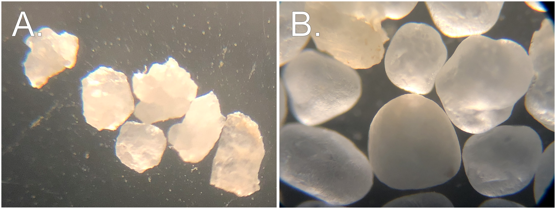

**Figure** **1**: Angular (A.) and well-rounded (B.) sands used for Experiment 1.

Experiment 2 evaluated the effect of sand-size uniformity for mixtures containing one of two sands having similar D50 but varying Cu. The two sands were produced from a single washed concrete sand having a wide particle size distribution. The original concrete sand was sieved to remove all particles >1 mm and <0.25 mm. The remaining fraction between 1 and 0.5 mm was riffled into two aliquots. The first aliquot remained untouched and is termed the “low-Cu sand”. The second aliquot, termed the “high-Cu sand”, had a portion of the removed particles (>1 mm and <0.25 mm) returned. This procedure created a wider particle-size distribution while maintaining a similar D50. Figure **2** shows the particle size distributions of the low-Cu and high-Cu sands. These sands meet the criteria of having similar D50 values (0.42 mm and 0.49 mm) but different Cu values (1.9 vs. 3.9). While the Cu value of 3.9 is still relatively low compared to natural alluvial sands, in this experiment the maximum obtainable Cu was limited by the maximum particle diameter of 2000 μm and the intentionally limited mass of particles <425 μm.

Each of these sands were mixed with a single illitic clay soil to yield mixtures having between 0 and 80% sand, for a total of 42 mixtures. Mixtures were produced at 5% sand content intervals between 0 and 50%, and a 2.5% interval between 50 and 80% sand. The increased spacing of data points between 50-80% sand was designed to provide better resolution near the threshold fines content.

The PL of the illitic clay soil used in Experiment 2 was 18 and its LL was 30, yielding a PI of 12. The particle size distribution of the clay soil is also shown in Figure **2**

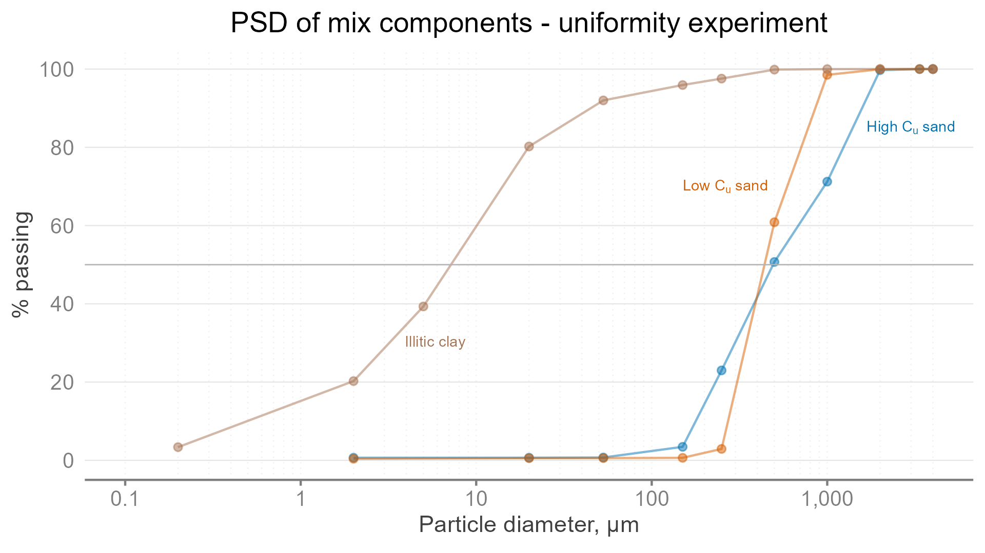

**Figure** **2**: Particle size distributions for the two sands and one clay used in Experiment 2. Dashed grey lines indicate $D_{50}$ for each sand.

## Statistical analysis and computational environment

LL and PL were the dependent variables in both experiments. A two-way ANOVA model was fitted to test the interaction effect between particle shape and percent sand (Table **1**) In Experiment 1, particle shape was considered a categorical predictor while a 2nd-order polynomial spline term was used to model percent sand as a continuous predictor. In Experiment 2, Cu was considered a categorical predictor while percent sand was treated as in Experiment 1. Main effects and interactions were tested using Type III Sums of Squares. Treatments were considered significantly different at α = 0.05.

All analyses were performed using the lm() function in the R Language for Statistical Computing (version 4.2.0) (Team, 2022). GNU Make (GNU, 2020) was used to facilitate reproducible analyses by maintaining links between raw data, analysis code, and finished output. Raw data and analysis code are included in the supplemental materials.

# Results and discussion

## Experiment 1: Effect of sand angularity

Experiment 1 compared the effect of angularity for two sands of equal size ranging from 0-80% sand. Figure **3** shows that the LL and PL were nearly identical for sand content <60%. At sand content ≥ 60%, a very slight increase in both LL and PL is visible for the angular sand, but this increase was not statistically significant.

The maximum difference between angular and round sand for any of the tests was 1.0 % water content. Under the conditions of this study, particle angularity is not important when sand size and sand contents are held constant.

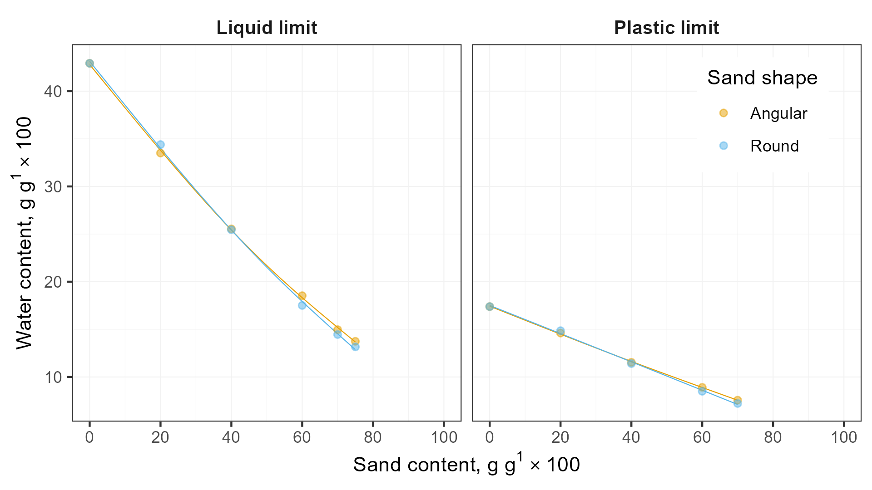

**Figure** **3**: The effect of particle shape on both the LL and PL tests was minimal.

**Table** **1**: Analysis of variance table for each characteristic water content in Experiment 1.

| Test type | Term | Sum Sq. | Deg. of Fr. | F-Statistic | P-value |
| --- | --- | --- | --- | --- | --- |
| LL | Intercept | 0.2102326912903 | 1 | 18,851.66965643 | 0.0000000000100668 |
| LL | % coarse addition | 0.0662850674506 | 2 | 2,971.90743044 | 0.0000000010255183 |
| LL | Shape | 0.0000065213769 | 1 | 0.58477510 | 0.4734399878822612 |
| LL | % coarse addition x Shape | 0.0000562492904 | 2 | 2.52195088 | 0.1603563444196159 |
| LL | Residuals | 0.0000669116408 | 6 |  |  |
| PL | Intercept | 0.0335886520089 | 1 | 7,179.25552295 | 0.0000001163025534 |
| PL | % coarse addition | 0.0065187687429 | 2 | 696.66246933 | 0.0000081945509973 |
| PL | Shape | 0.0000003502987 | 1 | 0.07487303 | 0.7979174584596617 |
| PL | % coarse addition x Shape | 0.0000107469506 | 2 | 1.14852933 | 0.4035008965942165 |
| PL | Residuals | 0.0000187142814 | 4 |  |  |

## Experiment 2: Effect of sand-size uniformity

The LL and PL of both mixtures including either sand were inversely proportional to sand content, up to the higher end of the range tested, above which the relationship is less clear. Both sands in Experiment 2 were relatively coarse (D50 of 0.42 and 0.49 mm), and the inverse relationship is in good agreement with other research on mixtures containing coarse sand (Mascitti and McNitt, Part I, this issue).

Mixtures produced with low-Cu sand had higher LL and PL than those produced using high-Cu sand (Figure **4**). This small effect was statistically significant for the LL but not for the PL (Table **Error! Reference source not found.**). Although this effect is measurable, it is probably of little practical significance. In Experiment 2, the sand content played a more dominant role on LL and PL than sand uniformity. While only a single clay was tested, the effect of varying the clay’s plasticity would likely affect LL and PL to a greater degree than varying the Cu of the sand.

A potential explanation for the slightly higher LL and PL (non significant) for the low-Cu sand is that the low-Cu sand contained more fine particles and therefore had a higher specific surface area (SSA). Finer particles would consume more water and could potentially reduce the water content of the clay matrix enough to alter LL and PL.

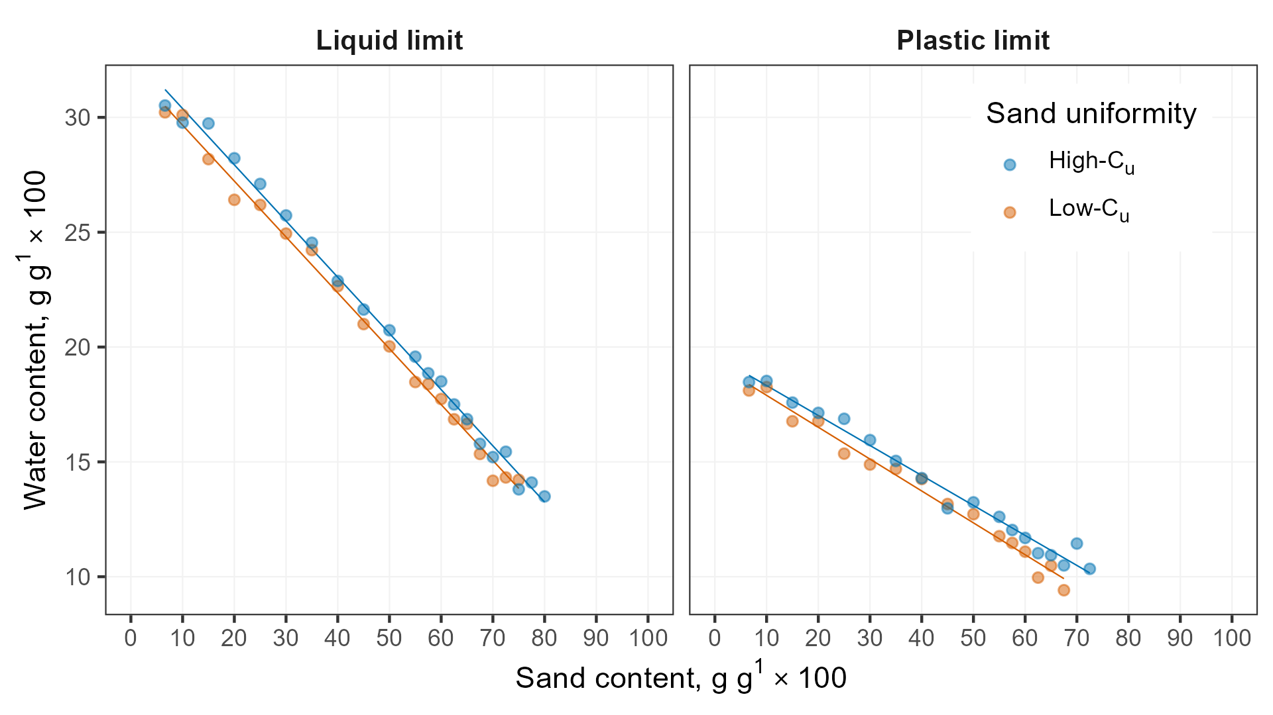

**Figure** **4**: The high-Cu sand had higher LL and PL than the low-Cu sand at nearly all sand contents.

## NULL is this a new heading? You need one here?

A more interesting feature of Experiment 2 was the different sand contents at which the mixtures became nonplastic. Low-Cu sand mixes containing 70, 72.5, and 75% sand could not be rolled out, but high-Cu mixes at these sand contents still had measurable plastic limits. Similarly, at sand content 75-80 %, the low-Cu mixtures slid along the base of the Casagrande cup (invalidating the test), whereas high-Cu sand mixtures flowed (rather than slid) and therefore had measurable liquid limits. These observations suggest that the threshold fines content is affected by sand uniformity.

In its pure state, non-uniform sand has less void space because the smaller sand particles fill some of the interstices among larger grains. This inter-packing reduces the volume of fines and water required to fill the voids, allowing the sand particles to begin “floating” at a higher total sand content.

Figure **5** shows conceptual diagrams of the particle arrangement at the TFC, along with a phase diagram depicting the volume occupied by each of the four phases (sand solids, clay solids, water, and air). When interpreting Figure **5** it is important to recall that sand content is normalized to mass while void ratio is normalized to volume. Total bulk volume is equivalent (i.e. 100%), but the mass fraction of sand is larger for the non-uniform sand when the sand content is normalized to the total solids mass (i.e. $\frac{m_{sand}}{m_{sand}+m_{clay}}$ ).

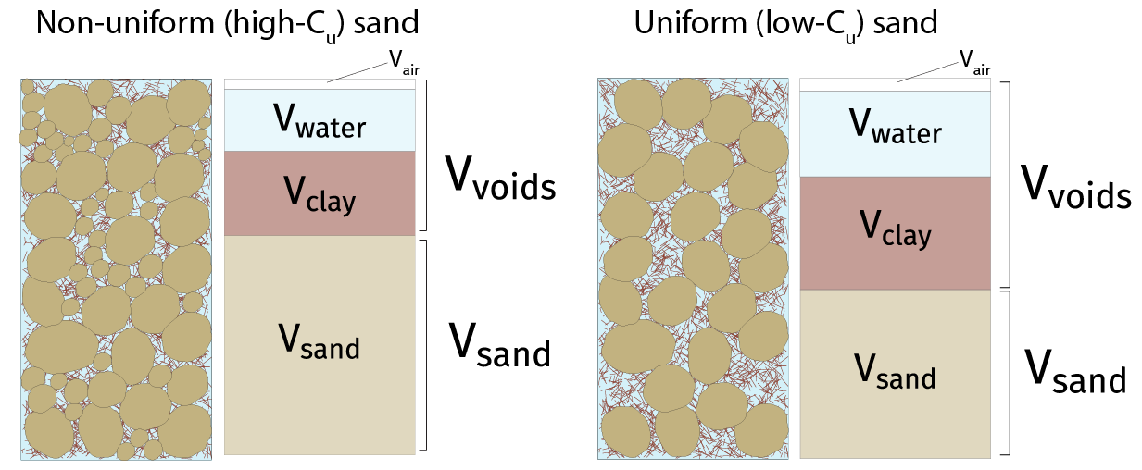

**Figure** **5**: Mixtures including less-uniform sand (left) should theoretically require fewer fines to fill their voids than those with more uniform sand (right).

To test the concept shown in Figure **5**, maximum void ratios $e_{sa \left(max\right)}$ for each sand were used to compute the sand content corresponding to the TFC (i.e. $m_{sa}=1-m_{fines}$ ). This state theoretically represents the sand content at which the sand grains begin to lose contact in the soil skeleton (Mitchell and Soga, 1993). The sand content at this boundary is computed as:

Equation dropped out?

where $m_{sa}$ is the sand mass, $w$ is the gravimetric water content, $S_{e}$ is the effective saturation, $G_{w}$ is the specific gravity of water at 20 °C, $G_{sa}andG_{c}$ are the specific gravities of the sand and clay, and $e_{sa}$ is the void ratio of the sand. A full derivation of Equation @ref(eq:tfc-equation) is available in the supplemental materials.

Effective saturation $S_{e}$ is the percent of voids occupied by water, normalized to the total porosity (Holtz et al., 2010). $S_{e}$ must be accounted for in Equation @ref(eq:tfc-equation) because it is unrealistic to expect complete air evacuation by simply compressing the soil with one’s fingers (Haigh et al., 2013). No attempt was made to measure $S_{e}$ directly from soil threads. The value of 0.9 was chosen based on literature regarding soil compaction tests ref?. Compacting a soil slightly wet of optimum typically yields $S_{e}$ ~0.9, regardless of compaction effort (Holtz et al., 2010; Gurtug and Sridharan, 2015; Rahman et al., 2022). There is also a good relationship between PL and the Proctor optimum water content, with PL being ~1.1 $w_{opt}$. same references? Therefore, the soils in this experiment would qualify as wet-of-optimum and would likely have $S_{e}$ ~0.9.

This calculation yielded sand contents of % for the low-Cu sand and % for the high-Cu sand. Recall that mixtures containing these sands became nonplastic at sand content of 67.5% and 72.5% respectively. Given the elementary nature of the PL test, the agreement between the calculations and experimental results is rather striking. This finding suggests TFC may be accurately computed from $e_{sa \left(max\right)}$.

The same calculation was made at the measured LL for the mixes containing the highest sand content at which the LL test could be performed without the soil sliding in the cup. Research has shown that even at the LL, $S_{e}$ is not complete and that $S_{e}$ asymptotically approaches 1 with increasing water content (Holtz et al., 2010; Guo and Wei, 2022). Therefore $S_{e}$ =0.95 was used along with LL water contents and Equation @ref(eq:tfc-equation) to yield calculated TFC values of and for the low-Cu and high-Cu sands. These closely match the sand contents at which the LL test became invalid (r) and r is something missing here? Need to see results/data

A final means to evaluate the status meaning floating? of the sand particles is intergranular porosity $n_{sa}$. This parameter represents the void volume between the sand grains if the fines are treated as voids along with the water and air (Lade et al., 1998b). It can be assumed that if $n_{s}a$ exceeds the porosity of the sand alone, the sand grains have begun to separate into a less-stable configuration. The $n_{sa} can be computed as:

where $m_{c}$ is the mass of the clay fraction, $m_{sa}$ is the mass of the sand fraction, $w$ is the water content, $S_{e}$ is effective saturation, and $G_{s}a$, $G_{c}$, and $G_{w}$ are the specific gravities of the sand, clay, and water phases.

Values for $n_{s}a$ were computed for the observed plastic limit water contents. Again, $S_{e}$ was assumed to be 0.9. Figure **6** plots $n_{sa}$ as a function of sand content for mixtures including either type of sand. The horizontal lines represents the maximum porosity of each sand with no fines added. Again, the computed $n_{sa}$ values agree closely with those observed at the sand contents required to make the soil nonplastic.

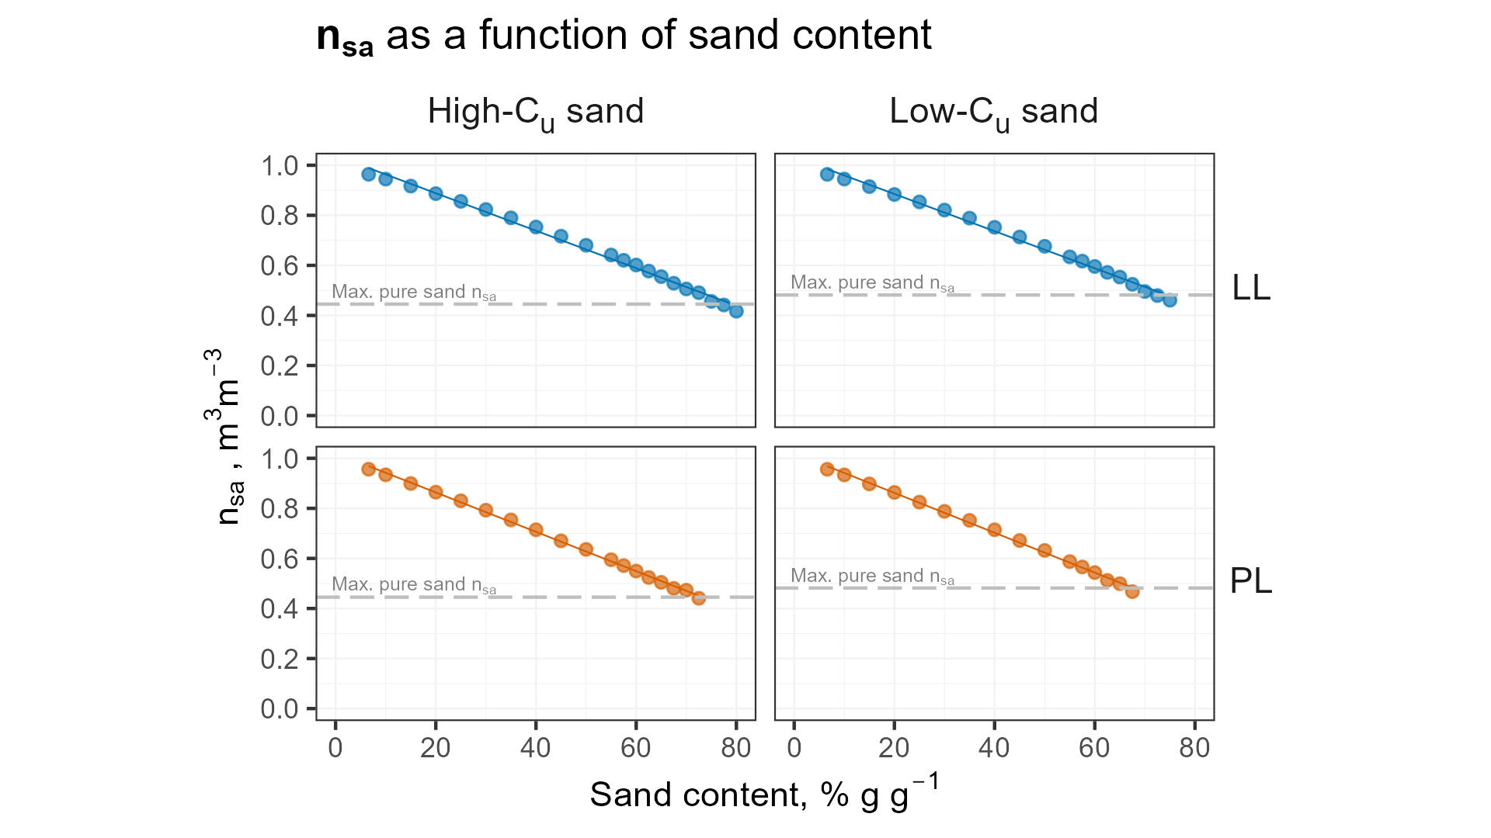

**Figure** **6**: Computed values for intergranular agreed closely with the sand content required to make the mixture nonplastic.

# Conclusions

This research demonstrated that, the effect of particle angularity on Atterberg limits of sand-clay mixtures is minimal and that the effect of sand uniformity is still small, but more notable.

In Experiment 2, Low-Cu mixtures had higher LL and PL compared to high-Cu mixtures with equivalent sand content. These results may be due to more inter-packing of sand particles within the high-Cu mixtures, which would require more water to separate the sand particles and permit sliding or slumping Alternatively, the higher LL and PL could be due to the higher specific surface area of the high-Cu sand.

Mixtures produced with the low-Cu sand became nonplastic at relatively? lower sand content. Less-uniform sands have fewer voids because smaller sand grains can fill the interstices between larger grains. This reduces the void volume available for the fines, which allow the granular particles to slide past one another and permit the soil to exhibit plasticity. Calculations for the threshold fines content and intergranular porosity agreed closely with observed LL and PL values. These results suggests the physical properties of the sand may be used to accurately predict the fines content marking a transition between plastic and nonplastic behavior. Needs further testing

Future work should investigate the potential (measure directly? Or directly test?) for relating the threshold fines content to Atterberg limits, and predicting TFC from a sand’s maximum void ratio. Additional research could evaluate potential interactions between sand uniformity and the plasticity of various clay, as well as test mixtures using higher Cu sands.

# Conflict of interest

The authors declare that there are no conflicts of interest.

# Author contributions

# References

Adams, W.A., and R.J. Gibbs. 1994. Natural Turf for Sport and Amenity. 1st ed. CABI International.

ASTM International. 2011. F1815-11 Standard Test Methods for Saturated Hydraulic Conductivity , Water Retention , Porosity , and Bulk Density of Athletic Field Rootzones. : 1–6. doi: [10.1520/F1815-11.2](https://doi.org/10.1520/F1815-11.2).

ASTM International. 2016. [4253-16: Test Methods for Maximum Index Density and Unit Weight of Soils Using a Vibratory Table](https://doi.org/10.1520/D4253-16). ASTM International.

ASTM International. 2017. [Test Methods for Particle-Size Distribution (Gradation) of Soils Using Sieve Analysis](https://doi.org/10.1520/D6913_D6913M-17). ASTM International.

ASTM International. 2018. D4318-17, Standard Test Methods for Liquid Limit, Plastic Limit, and Plasticity Index of Soils. : 20. doi: [10.1520/D4318-17E01.](https://doi.org/10.1520/D4318-17E01.)

Atterberg, A. 1911. Die Plastizität der Tone. Intern mitt. boden: 4–37.

Baker, B., Stephen W. (Sports Turf Research Institute). 2006. Rootzones, Sands and Top Dressing Materials for Sports Turf. Sports Turf Research Institute, West Yorkshire, England.

Barnes, G.E. 2013. The Plastic Limit and Workability of Soils. <https://www.escholar.manchester.ac.uk/api/datastream?publicationPid=uk-ac-man-scw:212752&datastreamId=FULL-TEXT.PDF>.

Brady, N.C., and R.C. Weil. 2007. The Nature and Properties of Soils. Prentice Hall, Upper Saddle River, NJ.

Dumbleton, M.J., and G. West. 1966. The influence of the coarse fraction on the plastic properties of clay soils- RRL Report No. 36. Road Research Laboratory, Crowthorne, Berkshire.

GNU. 2020. GNU Make. Free Software Foundation.

Guo, J., and X. Wei. 2022. The Influence of Soil Saturation on the Geotechnical Test Results (Y. Zhang, editor). Advances in Civil Engineering 2022: 1–6. doi: [10.1155/2022/7438757](https://doi.org/10.1155/2022/7438757).

Gurtug, Y., and A. Sridharan. 2015. Prediction of Compaction Behaviour of Soils at Different Energy Levels. Uluslararası Muhendislik Arastirma ve Gelistirme Dergisi: 15–18. doi: [10.29137/umagd.379757](https://doi.org/10.29137/umagd.379757).

Haigh, S.K., P.J. Vardanega, and M.D. Bolton. 2013. The plastic limit of clays. Géotechnique 63(6): 435–440. doi: [10.1680/geot.11.P.123](https://doi.org/10.1680/geot.11.P.123).

Hojae, Y., and A.S. McNitt. 2001. [Measurement of bulk mechanical properties of root-zone sand mixtures](https://doi.org/10.13031/2013.4119). 2001 Sacramento, CA July 29-August 1,2001. American Society of Agricultural and Biological Engineers

Holtz, R.D., W.D. Kovacs, and T.C. Sheahan. 2010. An Introduction to Geotechnical Engineering. Pearson, New York, NY.

Krumbein, W.C. 1941. Measurement and Geological Significance of Shape and Roundness of Sedimentary Particles. SEPM JSR Vol. 11. doi: [10.1306/D42690F3-2B26-11D7-8648000102C1865D](https://doi.org/10.1306/D42690F3-2B26-11D7-8648000102C1865D).

Lade, P.V., C.D. Liggio Jr., and J.A. Yamamuro. 1998a. Effects of Particle Shapes and Sizes on the Minimum Void Ratios of Sand. Geotechnical Testing Journal 21(4): 336–347.

Lade, P.V., C.D. Liggio Jr., and J.A. Yamamuro. 1998b. Effects of Non-Plastic Fines on Minimum and Maximum Void Ratios of Sand. Geotech. Test. J. 21(4): 336. doi: [10.1520/GTJ11373J](https://doi.org/10.1520/GTJ11373J).

Miller, N.A., and J.J. Henderson. 2011. Correlating Particle Shape Parameters to Bulk Properties and Load Stress at Two Water Contents. Agron. J. 103(5): 1514–1523. doi: [10.2134/agronj2010.0235](https://doi.org/10.2134/agronj2010.0235).

Mitchell, J.K., and K. Soga. 1993. Fundamentals of Soil Behavior. 3rd ed. Wiley.

Rahman, N., M. Islam, and A. Ullah. 2022. CORRELATION BETWEEN OPTIMUM MOISTURE CONTENT (OMC) AND PLASTIC LIMIT (PL) OF FINE GRAINED SOIL. DAFFODIL INTERNATIONAL UNIVERSITY JOURNAL OF SCIENCE AND TECHNOLOGY 17(1): 6.

Sibley, E.L.D., and C.P. Polito. 2020. [Insights on Threshold Fines Content](https://geovirtual2020.ca/wp-content/files/406.pdf). Geovirtual 2020 Resilience and Innovation

Sivapullaiah, P.V., and A. Sridharan. 1985. Liquid Limit of Soil Mixtures. Geotechnical Testing Journal 8(3): 111–116. doi: [10.1520/gtj10521j](https://doi.org/10.1520/gtj10521j).

Suhr, B., W.A. Skipper, R. Lewis, and K. Six. 2020. Shape analysis of railway ballast stones: Curvature-based calculation of particle angularity. Sci Rep 10(1): 6045. doi: [10.1038/s41598-020-62827-w](https://doi.org/10.1038/s41598-020-62827-w).

Team, R.C. 2022. [R: A language and environment for statistical computing. R Foundation for Statistical Computing](https://www.R-project.org/). Vienna, Austria.

Wadell, H. 1932. Volume, Shape, and Roundness of Rock Particles. The Journal of Geology 40(5): 443–451. <https://www.jstor.org/stable/30058012>.

Zuo, L., and B.A. Baudet. 2015. Determination of the transitional fines content of sand-non plastic fines mixtures. Soils and Foundations 55(1): 213–219. doi: [10.1016/j.sandf.2014.12.017](https://doi.org/10.1016/j.sandf.2014.12.017).